F:\Ravini\IJSElogo.png

## BSc (Hons) in computer Science

**GRADUATE DIPLOMA IN SOFTWARE ENGINEERING**

HOTEL MANAGEMENT SYSTEM

## J.Padeepa Chamika Kavithilaka

## 02/09/2021

## GDSE 58

## 2020/G/1073

|  |  |  |  |
| --- | --- | --- | --- |
| **Content** |  | | |
| **No** | **Title** | **Page No** |
| 1.0 | Introduction to Business | 2 |
| 2.0 | Overview of the proposed solution | 2 |
| 3.0 | Advantages of the solution | 2 |
| 4.0 | Use Case Diagram | 3 |
| 5.0 | Entity Relationship Diagram | 4 |

## Introduction to Business

* The name of project is “**Hotel Management System**”. The objective of the project is to computerize the system of the hotel. “**Hotel Management System**” is the project not only keeps the record of various people like customers, manager etc. but as well as it reduce the extensive paper work in the present system. It wills maker the system more versatile and user friendly. It also calculates the proper billing slip of high level and middle level customers. This project is based on description about the structure of **HOTEL MANAGEMENT SYSTEM**.

1. **Overview of the proposed solution**

* The hotel management system we are going to implement will be covering all the basic processes done in the hotel. it would handle guest details, reservation details, inventory management details, room service details and type.
* All the above mentioned details and information are stored in the system database. It could save time when retrieving data form the database. Interface will be designed user friendly and the functions will be displayed in a simple manner.

1. **Advantages of the solution**

1. Save time on admin tasks

2. Develop strong relationships with your guests

3. Implement an effective revenue management system

4. Accurate daily reports

5. Prevent double bookings and manual errors

6. Analyze your customer base

1. **Use Case Diagram**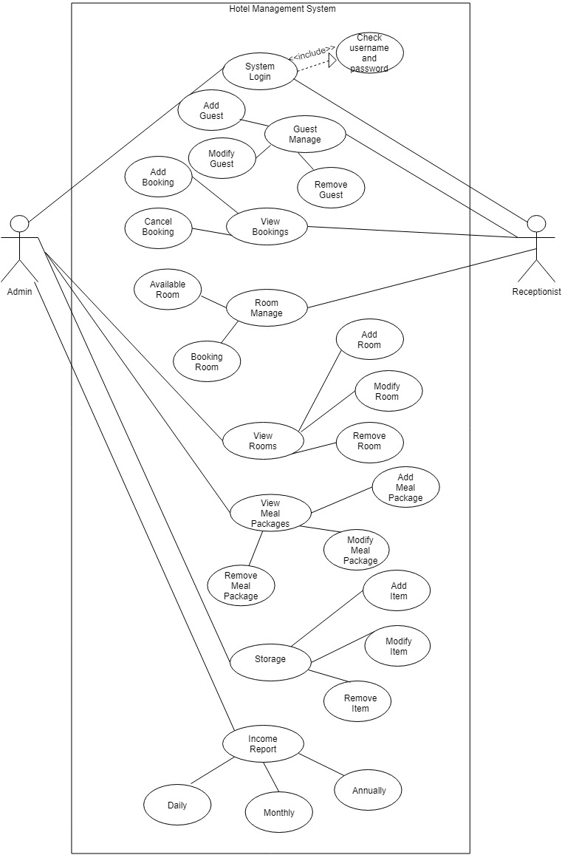
2. **Entity Relationship Diagram**

